FTP Server Configuration

What is FTP ?

File Transfer Protocol is one of the oldest

members of the TCP/IP protocol stack For Anonymous, yet it is

still in common use today. As the name suggests, it is

optimized for transferring files.

Daemon

vsftpd - Very Secure FTP Daemon

FTP Works
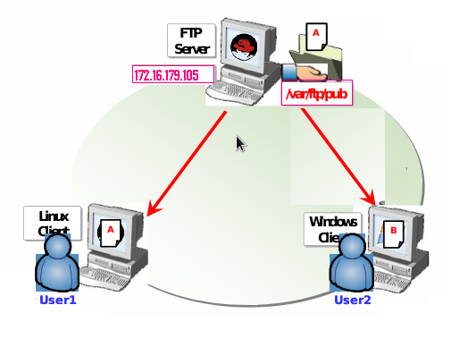

Requirements

Packages

vsftpd-2.2.2-3.fc13.i686

Port Numbers

20 Ftp Data Transfer

21 Ftp Control Connection

Configuration File

/etc/vsftpd/vsftpd.conf

Service

vsftpd

Default FTP Directory
for Anonymous User

/var/ftp/pub
Install the package by using one of the installation methods

[root@FTPServer Packages]# cd /media/Fedora\ 13\ i386\ DVD/Packages/

[root@ FTPServer Packages]# rpm -ivh vsftpd-2.2.2-3.fc13.i686.rpm –nodeps

OR
Install the package by using yum installation methods (Installation through Internet)

[root@FTPServer IT ~]# yum install vsftpd*

Open configuration for editing
for Anonymous User

[root@FTPServer IT]# vi /etc/vsftpd/vsftpd.conf

Change the Option Below

anonymous_enable=YES

local_enable=YES

dirmessage_enable=YES

ftpd_banner=Welcome to IT FTP service.

To restart the FTP services

[root@FTPServer IT]# service vsftpd restart

To make Service Permanently ON

[root@FTPServer IT]# chkconfig vsftpd on

Change the Permission of the Default Directory

[root@FTPServer IT]# chmod 776 /var/ftp/pub

In Client Side

[root@FTPUser1]# ftp 172.16.179.105

Connected to 172.16.179.105 (172.16.179.105).

220 Welcome to IT FTP service.

Name (172.16.179.105:IT): ftp

331 Please specify the password.

Password:
ftp
230 Login successful.

Remote system type is UNIX.

Using binary mode to transfer files.

ftp> ls

227 Entering Passive Mode (172,16,179,105,253,94).

150 Here comes the directory listing.
-rw-r--r-- 1 0 0 27 Dec 28 11:52 abc
-rw-r--r-- 1 0 0 18448 Nov 04 2011 rpmfusion-free-release-stable.noarch.rpm
-rw-r--r-- 1 0 0 31 Dec 28 11:53 ss
226 Directory send OK.
ftp> get abc
local: abc remote: abc
227 Entering Passive Mode (172,16,179,105,171,34).
150 Opening BINARY mode data connection for ss (31 bytes).
226 Transfer complete.
31 bytes received in 8.8e-05 secs (352.27 Kbytes/sec)
ftp> bye
221 Goodbye.
[root@ FTPServer IT]# ls
abc

Open configuration for editing
for NonAnonymous User

[root@FTPServer IT]# vi /etc/vsftpd/vsftpd.conf

Change the Option Below

anonymous_enable=NO

local_enable=YES

dirmessage_enable=YES

ftpd_banner=Welcome to IT FTP service.

save file by :wq

[root@FTPServer IT]# groupadd ftp-users

[root@FTPServer IT]# mkdir /ftp-docs

[root@FTPServer IT]# chmod 774 /ftp-docs

[root@FTPServer IT]# cd /ftp-docs

[root@FTPServer IT]# chwon root:ftp-users /ftp-docs

[root@FTPServer IT]# cd /ftp-docs

[root@FTPServer IT]# vi Myfile

Welcome FTP Service

Save :wq

[root@FTPServer IT]# ls

Myfile

[root@FTPServer IT]#useradd -g ftp-users –d /ftp-docs user1

[root@FTPServer IT]#passwd user1

abc

[root@FTPServer IT]# service vsftpd restart

[root@FTPServer IT]# chkconfig vsftpd on

In Linux Client Side

[root@FTPUser1]# ftp 172.16.179.105

Connected to 172.16.179.105 (172.16.179.105).

220 Welcome to IT FTP service.

Name (172.16.179.105:IT): user1
331 Please specify the password.

Password:
a1
230 Login successful.

Remote system type is UNIX.

Using binary mode to transfer files.

ftp> ls

227 Entering Passive Mode (172,16,179,105,253,94).

150 Here comes the directory listing.
-rw-r--r-- 1 0 0 27 Dec 28 11:52 Myfile
226 Directory send OK.
ftp> get Myfile
local: Myfile remote: Myfile
227 Entering Passive Mode (172,16,179,105,171,34).
150 Opening BINARY mode data connection for ss (31 bytes).
226 Transfer complete.
31 bytes received in 8.8e-05 secs (352.27 Kbytes/sec)
ftp> bye
221 Goodbye.
[root@ FTPServer IT]# ls

Myfile

In Windows Client Side

Open Mozilla Fire Fox browser. Or Internet explore

In the address box type:

ftp://172.16.179.105

